Country: Solomon Islands

ATLAS Project: 00080836

Project Title: Building Capacities for Peace and Development in the Solomon Islands

CPR TTF allocation: USD$500,000

Reporting period: 01/01/2015-31/12/2015

PROJECT PURPOSE

The overall purpose of the project is to lay the foundation for a multi-year social cohesion programme in the Solomon Islands. The project is designed to help build a cohesive and peaceful Solomon Island by empowering and building upon the resiliencies of national stakeholders to promote peacebuilding, conflict management, social cohesion strategies and processes. The project is also part of UNDPs larger initiative to support the Solomon Islands in developing a National Peacebuilding Policy (NPP) and framework that all stakeholders can sign onto and work to implement. Similar national policies do not exist in the Pacific region, and this NPP is the first of its kind.

Since the signing of the Townsville Peace Agreement in 2000 and the arrival of the Regional Assistance Mission to the Solomon Islands (RAMSI) in 2003, outstanding grievances are slowly being resolved. However, there remains a very ‘uneasy peace’ after the Tensions that gripped the country from 1998 to 2003, which severely limits the ability of the country to move towards a ‘unified, secure and viable nation.’ The lack of attention and limited communication from authorities, based in the capital Honiara, with the rest of the country accentuates the disparities in economic opportunities and political participation between different ethnic groups and continues to create potential disorder and fuels separatist sentiments. In addition to underlying political tensions, there has in recent years also been a dramatic increase in violent crime. A growing population, a disaffected youth and high unemployment are perceived to be driving forces behind this increase. The trend toward violence not only challenges law and order resources but also increases the possibility that vulnerable sections of society could be manipulated for politically motivated violence, which allegedly was the case during the 2006 Honiara Riots. Until today, the population as a whole (women, young people and the elderly in particular) continues to endure both physical and emotional trauma as the result of the conflict. Deep-seated distrust remains a significant factor to unity and peace. By strengthening the capacities, structures and systems of the Ministry of National Unity, Reconciliation and Peace (MNURP) and other stakeholders, the Solomon Islands Government will be better able to address the root-causes of potential violent conflict, and help mitigate the factors that can lead to the escalation of another violent conflict. To ensure sustainable peace, this project will work to strengthen current institutional capacities, strengthen relationships, mainstream conflict sensitive policies and programmes, support dialogue and other conflict resolution processes and lead public awareness campaigns.

The key objective of the programme is to advance a peaceful and united Solomon Islands, strengthen stability and foster social cohesion. The project proposes immediate assistance needed to deal with the current issues and unresolved business of the Tensions that continuously thwart developmental initiatives and at the same time contemplates the development of a longer term strategy for peace consolidation.

To address the challenges the key objectives of this project are to:

- Strengthen conflict resolution processes and develop national capacity
- Unresolved and sensitive issues from the Tensions as well as existing and emerging conflicts are effectively managed with appropriate technical assistance
- Solomon Island citizens engaged in building a more tolerant, peaceful and cohesive nation.
- Develop a nationally owned and driven multi-year project document on peacebuilding and social cohesion

RESULTS TO DATE

Since the beginning of 2015, the project has worked closely with MNURP in designing and planning various peacebuilding activities in the Solomon Islands. The projects provided support to the ministry on their work plans, strategic planning and monitoring and knowledge management. Through the deployment of the social cohesion specialist it provided support to the ministry aiming at more effective work by the ministry on conflict resolution and reconciliation at the sub national level, including the implementation of the nation-wide approach for peacebuilding in provinces.

The project implementation took momentum from February 2015. In the first quarter, the first Social Cohesion and Development Specialist spent his time doing courtesy calls to key Government Ministries and Project Coordinators of other UNDP Projects. In addition, the first Social Cohesion and Development Specialist also worked on the Framework for Multi-Year Project formulation and exploring potential expansion of the project. This framework created initiatives and identified opportunities for the Project’s work in 2015 and beyond.

Unfortunately after 4 month in office, the first Social Cohesion and Development Specialist left and a second Social Cohesion and Development Specialist was recruited in the second half of the year.

Through the deployment of a Social Cohesion and Development Specialist, this project aims to provide analytical and strategic advice to UNDP and the UNCT to create the conditions for their engagement in Solomon Islands in capacity building and high quality technical support, resilience, community cohesion and stability. This will identify strategies for underpinning support to the Government of Solomon Islands, post RAMSI support and to elaborate strategies and policies related to social cohesion and peace building.

The delay in recruiting the Social Cohesion and Development Specialist also created a delay in the implementation of the project, however, it gained momentum upon the arrival of the Specialist on 31 August 2016.

Upon the arrival of the Social Cohesion and Development Specialist, the project began to work in linking various initiatives within UNCT to become more conflict sensitive and mainstream social cohesion in their respective projects and programme.

Simultaneously, from 2nd to 4th September 2015 the project under the overall guidance of the Crisis Prevention and Recovery portfolio conducted an Urban Youth Policy Review Workshop in collaboration with the Honiara City Council. The workshop brought together 50 youth leaders from within the Honiara City boundary to review the Urban Youth Policy and provide the opportunity to:
- Identify gaps within the Policy and the implementation of its last cycle
- Bring more awareness and understanding to the Policy
- Look at the opportunity to create linkages between the Urban Youth Policy, National Youth Policy and the National Peacebuilding Policy
- Create a Way Forward that could address the implementation of the new cycle

The workshop was the first of its kind since the development of the Urban Youth Policy. It was also noted that the Policy was designed with very limited input of youths within the urban setting. As such, this project ensured that this workshop was led and owned by the 50 youth leaders to inform the new cycle of the Urban Youth Policy.

As a result, Honiara City Council Youth Division reported an increase in the youth lead community meetings and the new enthusiasm in youth participation to the Youth Division activities. Recognizing the need to continue to support Youth initiatives within the Solomon Islands, a youth component has been reflected in the Long Term Peacebuilding project, which is now in the hard pipeline. This will ensure a wider participation of youths not only in Honiara but also other parts of the country.

The National Peacebuilding Policy, to which UNDP played a key role in the development and consultations with the Ministry of National Unity, Reconciliation and Peace was endorsed in July 2015, was seen as a platform to advance the agenda of Peacebuilding and Social Cohesion of the country. Through this project, UNDP played a significant role in supporting the Ministry of National Unity, Reconciliation and Peace (MNURP) to ensure effective planning for the implementation of the national peace policy. The development of the work plan in 2016 was facilitated jointly between UNDP and the Ministry.

In late 2015, the project initiated and facilitated 3 multi-stakeholder dialogues on governance, stability and social cohesion, which became a regular forum (on monthly basis) between key stakeholders to discuss social and political issues, especially with regard to RAMSI exit and transition. This forum is the first of its kind and is now recognized and known nationally as the platform for multi stakeholders’ discussion on social and political issues with great support and interest from national and international stakeholders These forums have also created an improved coordination opportunity for information sharing between national agencies, international development partners and key policy makers in Honiara as well as created an understanding to advancing the work of Peacebuilding and Social Cohesion within the country.

The project also provided support to assist with the capacity building programme of the ministry. Knowledge sharing and experiences on reconciliation and rehabilitation of post conflict societies was shared with the ministry through intensive engagements and meetings with the departments and units within MNURP.

To continue support from the international partner, the project intensified engagement with development partners and presented various programmes areas to be implemented by UNDP to support transition and stability. Consultations with communities, key national stakeholders and development partners continued, to formulate the multi-year programme to support national efforts on pursuing stability, reconciliation and national unity in Solomon Islanders beyond the issues of the two provinces – Guadalcanal and Malaita. The formulation of the multiyear programme has led to a stronger level of support to the Solomon Island peacebuilding programme, including resulted in the application by UNDP and UN Women for the peace building fund.

At the provincial level, engagements and consultations with provincial stakeholders included a visit to provinces to meet key government officials. The visit to Western and Choiseul Provinces were conducted on 23 – 30 October 2015. Stronger communication and engagement with policy makers in Honiara has improved significantly with regular advice provided to the MNURP and the PMO.

Implementation constraints and lessons learned:
- There was a difficulty in conducting field visits due to limited transportation services and remoteness of many places.
- Very limited amount of funds available to actually implement the social cohesion and peacebuilding programme.
- Political instability and uncertainty affected the capacity to fully engage and mainstream social cohesion in various national programmes.

FUTURE WORK PLAN/ Activities to be undertaken

The recruitment of the Social Cohesion and Development Specialist is decisive for implementation of the social cohesion programme with various key activities to be implemented in 2015. The remaining budget is 162,525 and the project will end in December 2016 unless no extension is requested and approved.

Future focus of the project:
- Continue to support building stronger capacity of the MNURP in the area of social cohesion, peacebuilding programming and implementation, coordination and effort to support better engagement with other national stakeholders. Providing substantive and technical support to MNURP and PMO to coordinate peacebuilding work, including policy formulations, and on specific issues;
- Timely support to substantive social cohesion and peacebuilding activities (when gaps in government and other resources are evident) through grants. These will be undertaken coherently within the plan, and relevant to the peacebuilding implementation overall.
- Working to ascertain entry points identified for longer-term UNDP engagement in social cohesion and peacebuilding programme in the Solomon Islands beyond 2016, especially in the context of post RAMSI transition in the country.
- Support to various local initiatives from local NGOs and young people to encourage active public active participation in peacebuilding activities and awareness campaign.
- Building stronger linkage between the existing social cohesion project and the immediate peacebuilding project to be supported under Peace Building Fund.

FINANCIAL IMPLEMENTATION

The total budget of the project allocated for 2015 was USD$227,100.00

Year | Budget | Expenditure | Delivery
January - December 2015 | 227,100.00 | 236,649.95 | 100%
January – December 2016 | 262,525.00 | 79,207.88 | 30% (May 2016)
Total | 489,625.00 | 315,857.83

Executive Snapshot page: Commitment Control Budget Details -2015
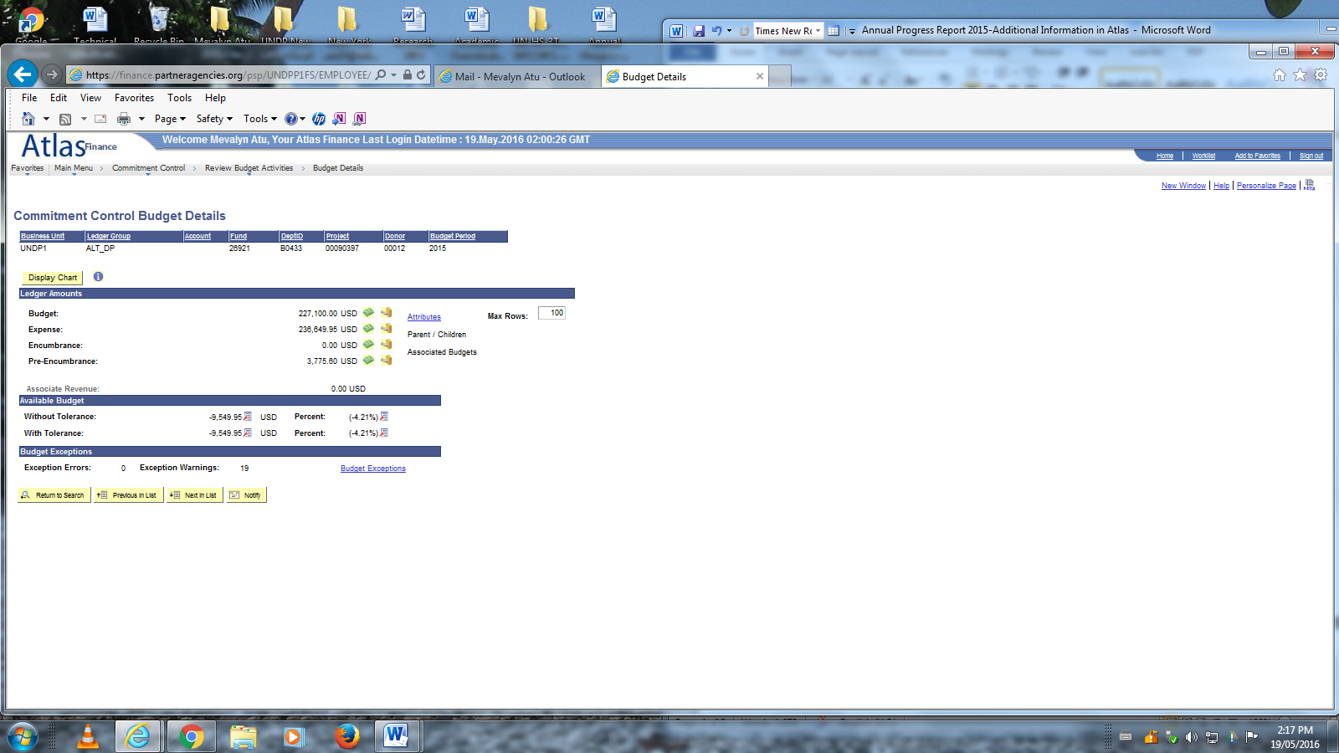
Executive Snapshot page: Commitment Control Budget Details -2016
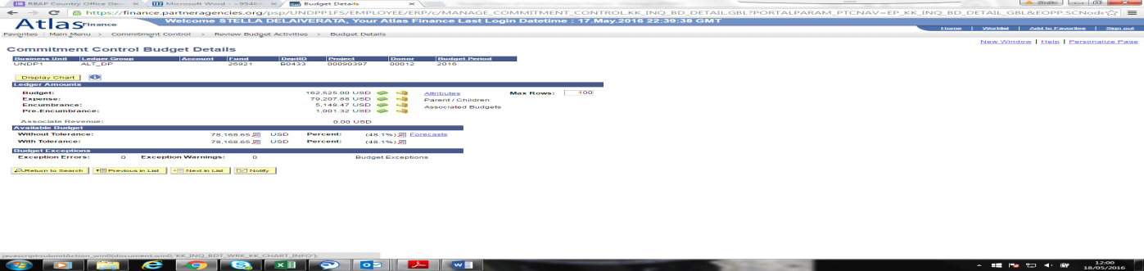

Contact Details:

Name: Azusa Kubota
Title: UNDP Country Manager
UNDP Sub Office Honiara
Azusa.kubota@undp.org
+ 677

Name: Agus Wandi
Title: Social Cohesion and Development Specialist
UNDP Sub Office Honiara
Agus.wandi@undp.org
+ 6778797304

